
INTELLIGENT PRECISION COUPLING
IPK

WITH INTEGRATED MEASUREMENT UNIT | BATTERY

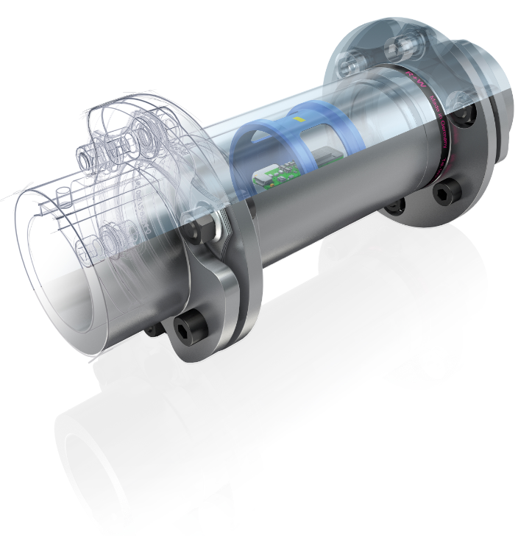   | PROPERTIES
 | FEATURES  - Measurement of different dimensions  - Measurement error < 1% (torque)  - Integrated measurement amplifier  - Display of the data on mobile device  - Data export as CSV-file | SPEZIFICATIONS  - Bluetooth 5.0 Low Energy  - Magnetic charging plug  - Sample rate up to 500 Hz  - Recording rate up to 500 Hz  - Speed resistance up to 8000 1/min
 | MEASURED DIMENSIONS  - Torque  - Rotation speed up to 2500 1/min  - Acceleration  - Optional: push / pull forces | DESIGN  - Standard coupling with integrated sensors  - Unchanged mechanical properties  - Custom design on request

POWER SUPPLY VIA BATTERY
- No wires necessary
- Simple mounting
- For mobile applications
- High battery life

COMPATIBLE COUPLINGS
LINE-SHAFTS | DISC-PACK-COUPLINGS | SAFETY-COUPLINGS | STIFF COUPLINGS
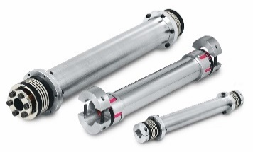  ZA | ZAE | EZ2 | 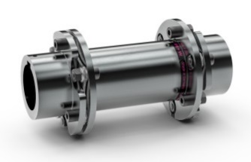  LP2 | LP3 | LP5 | LPH | 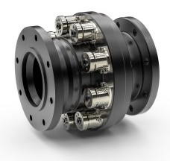  STF | 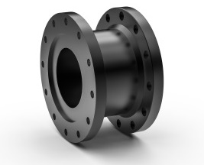  Flange adapter

PROVISION OF MEASURED DATA
R+W GATEWAY  - Connection on PC / SPS / Cloud solutions  - USB-C Port (UART)  - 8 analog outputs (-10 to +10 V)  - Output of measured values  - 8 digital outputs  - Status of connection  - Signal of occurred events  - SMA connector for external antenna  R+W APP  - Display of all measured values  - Min- / Max- and average values  - Zeroing of values  - Different types of diagrams  - Detailed progress of measured data  - Intuitive gesture control  - Recording measurements for analytics e.g. in MS Excel  - Data export as CSV-file | 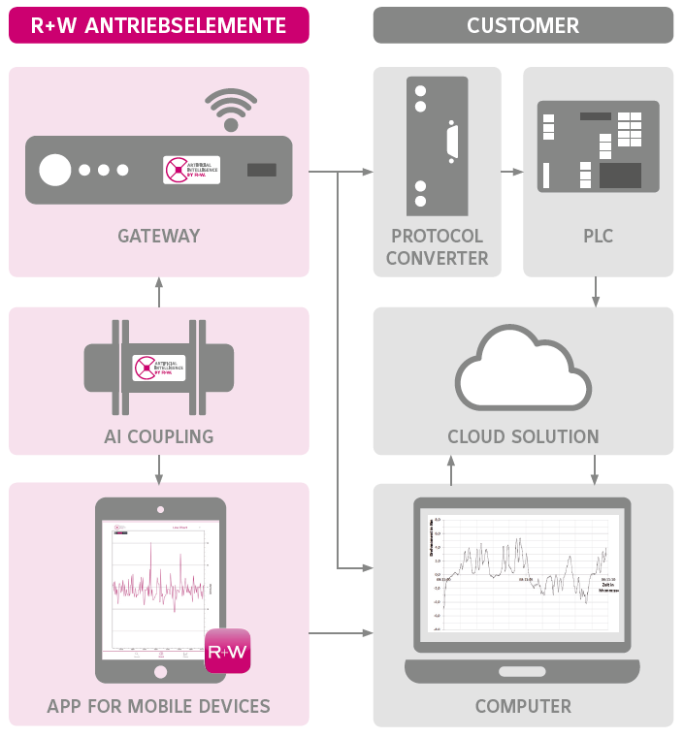

TECHNICAL DATA – INTELLIGENT PRECISION COUPLING
  TORQUE MEASUREMENT
  Resolution | 24 | bit
  Sample rate | 1 – 500 | Hz
  Error of indication | < 1 | %
  SPEED MEASUREMENT
  Resolution | 16 | bit
  Sample rate | 1 – 500 | Hz
  Error of indication 0…660 1/min | 0,5 | %
  Error of indication 660…2500 1/min | 5 | %
  ACCELERATION MEASUREMENT
  Number of axes | 3
  Acceleration (max.) | 30 | g
  Resolution | 16 | bit
  Sample rate | 1 – 500 | Hz
  OPTIONAL PUSH / PULL FORCE MEASUREMENT
  Resolution | 24 | bit
  Sample rate | 1 – 500 | Hz
  Error of indication | < 2 | %
  OPERATION
  Max. rotation speed | 8000 | 1/min
  Ambient conditions | normal
  Temperature | -20 – 60  -4 – 140 | °C  °F
  rel. centrifugal acceleration | 130 | g
  ESD | 4 | kV
  Protection class | IP 65
  POWER SUPPLY
  Battery type |  | Li-Ion | Battery
  Capacity |  | 320 / 3400 | mAh
  Charging voltage |  | 5 | V
  Charging connection |  | magnetic plug
  Charging time |  | ca. 2 – 3 | h
  Power consumption¹ |  | 15 | mA
  Min. battery life¹ |  | 20 | h
  Max. battery life² |  | 150 | Days
  Standby current³ |  | 0,1 | mA
  Idle mode current⁴ |  | 5 | µA
  ¹ | With permanent 500 Hz sample rate and optional axial force measurement and smallest size
  ² | With permanent 10 Hz sample rate and high battery capacity
  ³ | Visible in R+W App
  ⁴ | Not visible, activation per magnetic plug
  INCLUDED ACCESSORIES
  1x | Magnetic charging cable
  1x | Calibration certificate
  1x | Operation manual
  OPTIONAL ACCESSORIES
  1x | Magnetic charging cable
  1x | Gateway

TECHNICAL DATA – R+W APP
  DATA TRANSFER
  Frequency |  | 2,45 | GHz
  Bluetooth version |  | 5.0
  Simultaneous connected IPKs |  | 4
  Latency |  | < 150 | ms
  Synchronicity |  | ± 25 | ms
  Transmission power (max.) |  | 4 | dBm
  Reception strength (min.) |  | -90 | dBm
  Range¹ |  | ca. 10 | m
  ¹ | Specification valid for unobstructed view. With partial shielding, the range can be significantly reduced.
  DATA STORAGE
  Record frequency | 1 - 500 | Hz
  Storage size | 512 | Mb
  Memory per measurand | 5,4 | Mb/h
  SYSTEM REQUIREMENTS
  Operating system | min. Android 6.0
  Bluetooth version | min. 4.0, better 5.0
  Storage size for App | min. 30 | Mb
  Data export format | CSV-file
  Synchronization | Unix Time Stamp

TECHNICAL DATA – GATEWAY (OPTIONAL)
The connections for supply and outputs are located on the top and bottom side of the gateway.  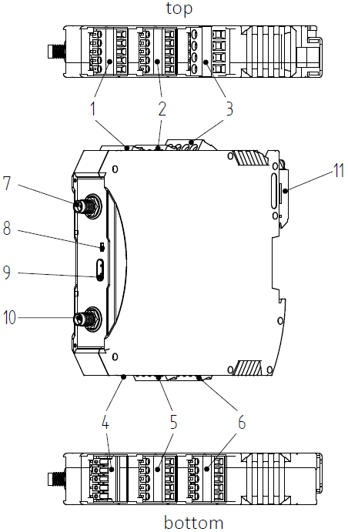
  POS. | DESCRIPTION
  1 | Digital outputs (do)
  2 | Digital outputs (do)
  3 | Power in (24 V) / power out (12 V)
  4 | Not used / debug
  5 | Analog outputs (ao)
  6 | Analog outputs (ao)
  7 | External antenna connection, signal input
  8 | Status LED
  9 | USB-C port
  10 | External antenna connection, signal output
  11 | Fastening for mounting rail
TECHNICAL DATA – GATEWAY (CONTINUATION)
  ANALOG OUTPUTS
  Amount | 8
  Voltage range | ± 10 | V
  Resolution | 16 | bit
  Linearity deviation | < 1 | %
  Max. load | 20 | mA
  DIGITAL OUTPUTS
  Amount | 8
  Voltage | 24 | V
  Max. load | 0,5 | A
  SERIAL OUTPUT (UART)
  Amount | 1
  Baud rate | Adjustable
  Stop bits | 1
  Parity | None
  Data bits | 8
  DATA TRANSFER
  Frequency |  | 2,45 | GHz
  Bluetooth version |  | 5.0
  Simultaneous connected IPKs |  | max. 4
  Transmission rate¹ |  | up to 500 | Hz
  Latency |  | < 150 | ms
  Synchronicity |  | ± 25 | ms
  Transmission power (max.) |  | 4 | dBm
  Reception strength (min.) |  | -90 | dBm
  Range¹ |  | 10 | m
  ¹ | Specification valid for unobstructed view. With partial shielding, the range can be significantly reduced.
  POWER SUPPLY
  Supply voltage | 24 | V
  Current consumption (typ./max.) | 50 / 100 | mA
  Power consumption (typ./max.) | 1,2 / 2,4 | W
  OPERATION
  Temperature | -20 – 60  -4 – 140 | °C  °F
  Protection class | IP 20
  Mounting rail | DIN EN 50022
  PIN ASSIGNMENT
  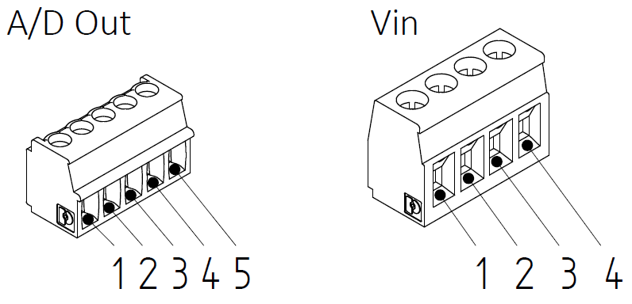
  PIN | POS. 1 | POS. 2 | POS. 3 | POS. 5 | POS. 6
  1 | do5 | do1 | n.c. | GND | GND
  2 | do6 | do2 | GND | ao8 | ao4
  3 | do7 | do3 | n.c. | ao7 | ao3
  4 | do8 | do4 | 24 V | ao6 | ao2
  5 | GND | GND | - | ao5 | ao1
  DIMENSION OF HOUSING
  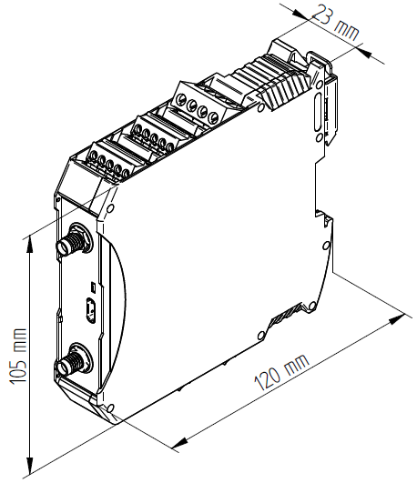 | Weight: approx. 150 g
  INCLUDED ACCESSORIES
  2x | Antenna (Laird, 001-0001)
  1x | Connector, 4-pin  (Amphenol, 20020006-G041B01LF)
  4x | Connector, 5-pin  (Amphenol, TJ0511530000G)
  OPTIONAL ACCESSORIES
  1x | 24 V power supply unit, 36 W AC/DC  (GlobTek, RR9LI1500LCPIMNAR6B)
  1x | Power supply adapter cable
  1x | USB-C to USB-A Kabel, 1 m

R+W Antriebselemente GmbH
Hattsteinstraße 4 · D-63939 Wörth am Main
Tel. +49 9372 9864-0 · Fax +49 9372 9864-20
info@rw-kupplungen.de · www.rw-couplings.com

