
INTELLIGENT PRECISION COUPLING
IPK

WITH INTEGRATED MEASUREMENT UNIT | INDUCTION

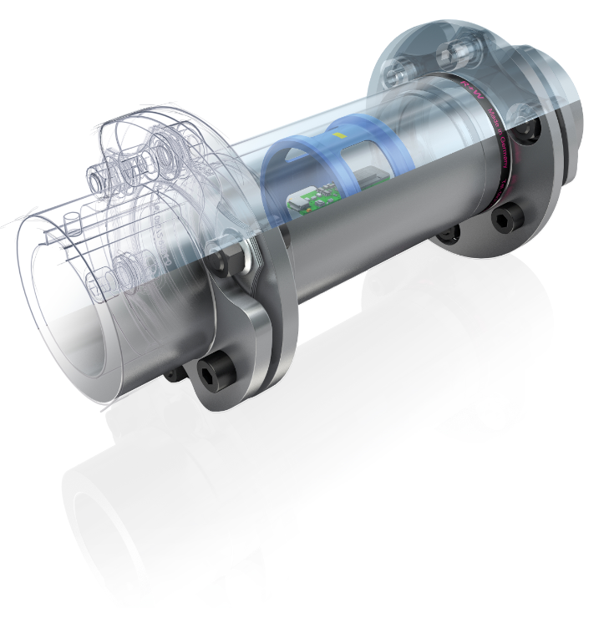   | PROPERTIES
 | FEATURES  - Measurement of different dimensions  - Measurement error < 1% (torque)  - Integrated measurement amplifier  - Display of the data on mobile device  - Data export as CSV-file  - Data transfer via Gateway | SPEZIFICATIONS  - Bluetooth 5.0 Low Energy  - Inductive power supply  - Sample rate up to 500 Hz  - Recording rate up to 500 Hz  - Speed resistance up to 8000 1/min
 | MEASURED DIMENSIONS  - Torque  - Rotation speed  - Acceleration  - Optional: push / pull forces | DESIGN  - Standard coupling with integrated sensors  - Unchanged mechanical properties  - Custom design on request

POWER SUPPLY VIA INDUCTION
- Permanent power supply
- Suitable for permanent measuring tasks and fixed installation in plants and test benches
- Condition monitoring of machines and systems in series
- Torque control of industrial processes
- Quality assurance and monitoring of production processes

COMPATIBLE COUPLINGS
LINE-SHAFTS | DISC-PACK-COUPLINGS | SAFETY-COUPLINGS | STIFF COUPLINGS
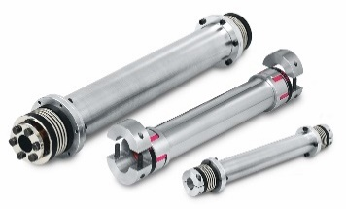  ZA | ZAE | EZ2 | 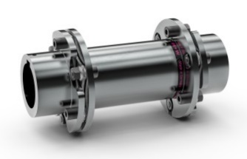  LP2 | LP3 | LP5 | LPH | 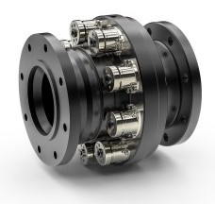  STF | 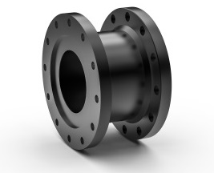  Flange adapter

PROVISION OF MEASURED DATA
R+W GATEWAY  - Connection on PC / SPS / Cloud solutions  - USB-C Port (UART)  - 8 analog outputs (-10 to +10 V)  - Output of measured values  - 8 digital outputs  - Status of connection  - Signal of occurred events  - SMA connector for external antenna  R+W APP  - Display of all measured values  - Min- / Max- and average values  - Zeroing of values  - Different types of diagrams  - Detailed progress of measured data  - Intuitive gesture control  - Recording measurements for analytics e.g. in MS Excel  - Data export as CSV-file | 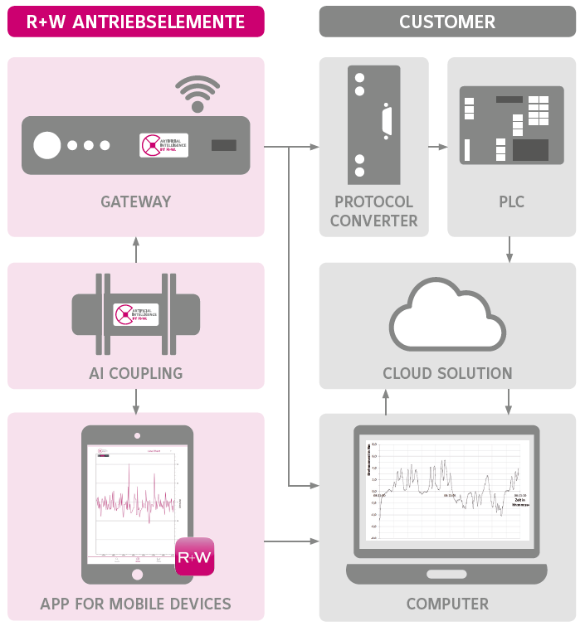

BUILDUP

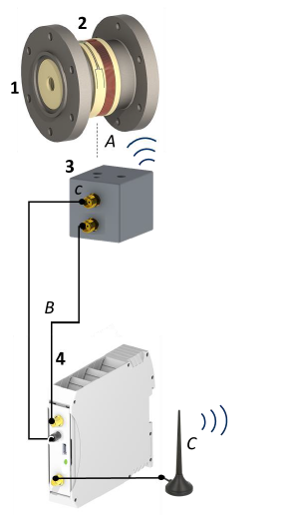
The inductive transmission unit consists of an Intelligent Coupling (1), a coil (2) wound around the component, a pick-up (3) and a gateway (4). The pick-up must be positioned close to the rotating coil for uninterrupted power transmission (A). The connection to the gateway is made via two cables (B).

The gateway is operated wirelessly via the R+W App (C). The user can connect to the gateway to change settings or display measured values. The antenna (C) should be positioned near the end device (tablet or smartphone).

The following functions are provided via the app:
- Commissioning of the inductive coupling
- Definition of threshold values and configuration of the data logger
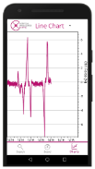
- Download of stored measurement data
- Display and log measured values at up to 500 Hz in parallel with analog output
- Change settings (name, calibration values, taring)

TECHNICAL DATA – INTELLIGENT PRECISION COUPLING
  TORQUE MEASUREMENT
  Resolution | 24 | bit
  Sample rate | 1 – 500 | Hz
  Error of indication | < 1 | %
  SPEED MEASUREMENT
  Resolution | 16 | bit
  Sample rate | 1 – 500 | Hz
  Error of indication 0…660 1/min | 0,5 | %
  Error of indication 660…2500 1/min | 5 | %
  ACCELERATION MEASUREMENT
  Number of axes | 3
  Acceleration (max.) | 30 | g
  Resolution | 16 | bit
  Sample rate | 1 | kHz
  OPTIONAL PUSH / PULL FORCE MEASUREMENT
  Resolution | 24 | bit
  Sample rate | 1 – 500 | Hz
  Error of indication | < 2 | %
  OPERATION
  Max. rotation speed | 8000 | 1/min
  Ambient conditions | normal
  Temperature | -20 – 60  -4 – 140 | °C  °F
  rel. centrifugal acceleration | 130 | g
  ESD | 4 | kV
  Protection class | IP 65
  OPTIONAL SPEED SENSOR
  For higher accuracy or a measuring range above 2500 1/min, an optional speed sensor can be installed. Further details on request.
  INCLUDED ACCESSORIES
  1x | Calibration certificate
  1x | Operation manual

TECHNICAL DATA – GATEWAY
The connections for supply and outputs are located on the top and bottom side of the gateway.  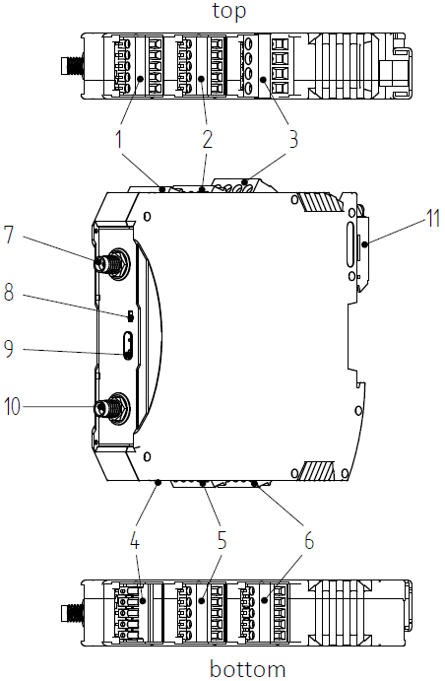
  POS. | DESCRIPTION
  1 | Digital outputs (do)
  2 | Digital outputs (do)
  3 | Power in (24 V) / power out (12 V)
  4 | Not used / debug
  5 | Analog outputs (ao)
  6 | Analog outputs (ao)
  7 | External antenna connection, signal input
  8 | Status LED
  9 | USB-C port
  10 | External antenna connection, signal output
  11 | Fastening for mounting rail

TECHNICAL DATA – GATEWAY (CONTINUATION)
  ANALOG OUTPUTS
  Amount | 8
  Voltage range | ± 10 | V
  Resolution | 16 | bit
  Linearity deviation | < 0,1 | %
  Max. load | 20 | mA
  DIGITAL OUTPUTS
  Amount | 8
  Voltage | 24 | V
  Max. load | 0,5 | A
  SERIAL OUTPUT (UART)
  Amount | 1
  Baud rate | Adjustable
  Stop bits | 1
  Parity | None
  Data bits | 8
  DATA TRANSFER
  Frequency |  | 2,45 | GHz
  Bluetooth version |  | 5.0
  Latency |  | < 150 | ms
  Synchronicity |  | ± 25 | ms
  Transmission power(max.) |  | 4 | dBm
  Reception strength (min.) |  | -90 | dBm
  Range¹ |  | 10 | m
  ¹ | Specification valid for unobstructed view. With partial shielding, the range can be significantly reduced.
  POWER SUPPLY
  Supply voltage | 24 | V
  Current consumption (typ. / max.) | 50 / 100 | mA
  Power consumption (typ. / max.) | 1,2 / 2,4 | W
  OPERATION
  Temperature | -20 – 60  -4 – 140 | °C  °F
  Protection class | IP 20
  Mounting rail | DIN EN 50022
  PIN ASSIGNMENT
  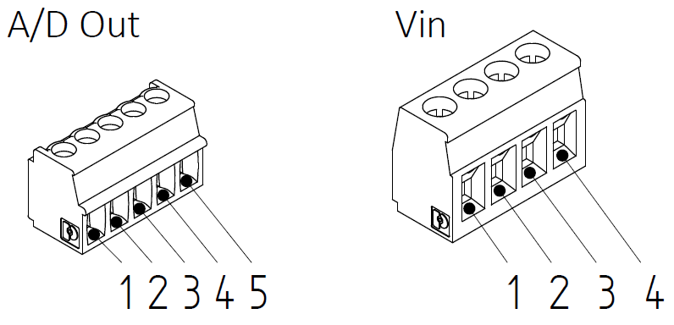
  PIN | POS. 1 | POS. 2 | POS. 3 | POS. 5 | POS. 6
  1 | do5 | do1 | n.c. | GND | GND
  2 | do6 | do2 | GND | ao8 | ao4
  3 | do7 | do3 | n.c. | ao7 | ao3
  4 | do8 | do4 | 24 V | ao6 | ao2
  5 | GND | GND | - | ao5 | ao1
  DIMENSION OF HOUSING
  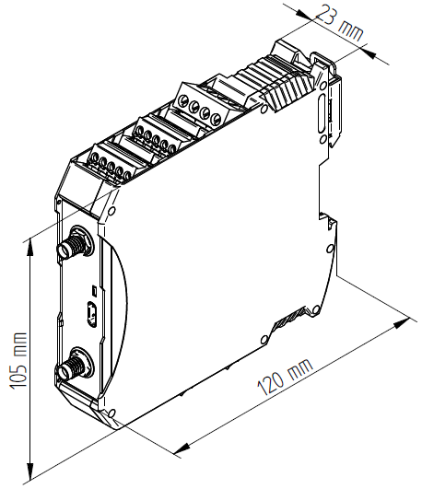 | Weight: approx. 150 g
  INCLUDED ACCESSORIES
  1x | Cable pick-up – Gateway 1,5 m
  2x | Antenna extension cable 1,5 m
  1x | Antenna (Laird, 001-0001)
  1x | Connector, 4-pin  (Amphenol, 20020006-G041B01LF)
  4x | Connector, 5-pin  (Amphenol, TJ0511530000G)
  OPTIONAL ACCESSORIES
  1x | 24 V power supply unit, 36 W AC/DC  (GlobTek, RR9LI1500LCPIMNAR6B)
  1x | Power supply adapter cable
  1x | USB-C to USB-A cable, 1 m

TECHNICAL DATA –PICK-UP
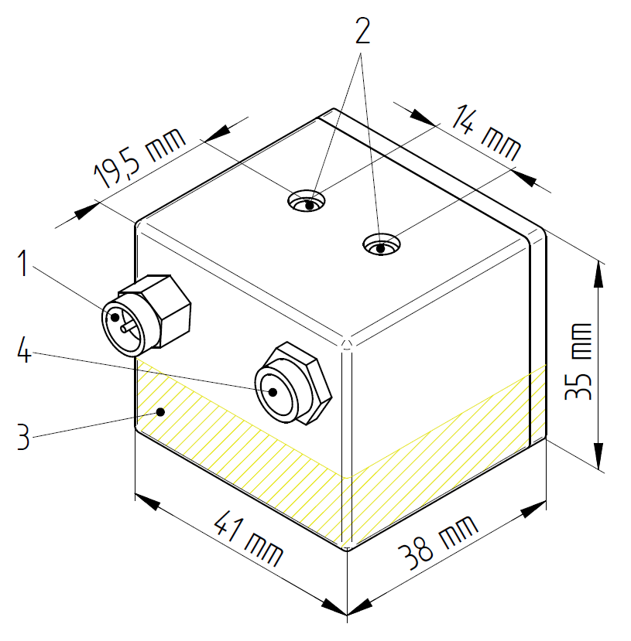  Fastening of the pick-up via two M4 threaded holes (2). The stator coil is located in the yellow shaded area. The 41x38 mm² bottom of the housing is positioned at a distance of 1 to 10 mm from the rotor coil. Avoid metallic components in the immediate vicinity next to the rotor component and the coil, as this will reduce the reception quality.
  POS. | DESCRIPTION
  1 | SMA connector
  2 | M4 threaded holes for mounting
  3 | Stator coil
  4 | Electric connector
  PICK-UP
  Distance pick-up / shaft | 1…10 | mm
  Material | plastic
  Mounting | M4 screws
TECHNICAL DATA – R+W APP
  DATA TRANSFER
  Frequency |  | 2,45 | GHz
  Bluetooth version |  | 5.0
  Simultaneous connected IPKs |  | max. 4
  Latency |  | < 150 | ms
  Synchronicity |  | ± 25 | ms
  Transmission power (max.) |  | 4 | dBm
  Reception strength (min.) |  | -90 | dBm
  Range¹ |  | ca. 10 | m
  ¹ | Specification valid for unobstructed view. With partial shielding, the range can be significantly reduced.
  DATA STORAGE
  Record frequency | 1 - 500 | Hz
  Storage size | 512 | Mb
  Memory per measurand | 5,4 | Mb/h
  SYSTEM REQUIREMENTS
  Operating system | min. Android 6.0
  Bluetooth version | min. 4.0, better 5.0
  Storage size for App | min. 30 | Mb
  Data export format | CSV-file
  Synchronization | Unix Time Stamp

R+W Antriebselemente GmbH
Hattsteinstraße 4 · D-63939 Wörth am Main
Tel. +49 9372 9864-0 · Fax +49 9372 9864-20
info@rw-kupplungen.de · www.rw-couplings.com

