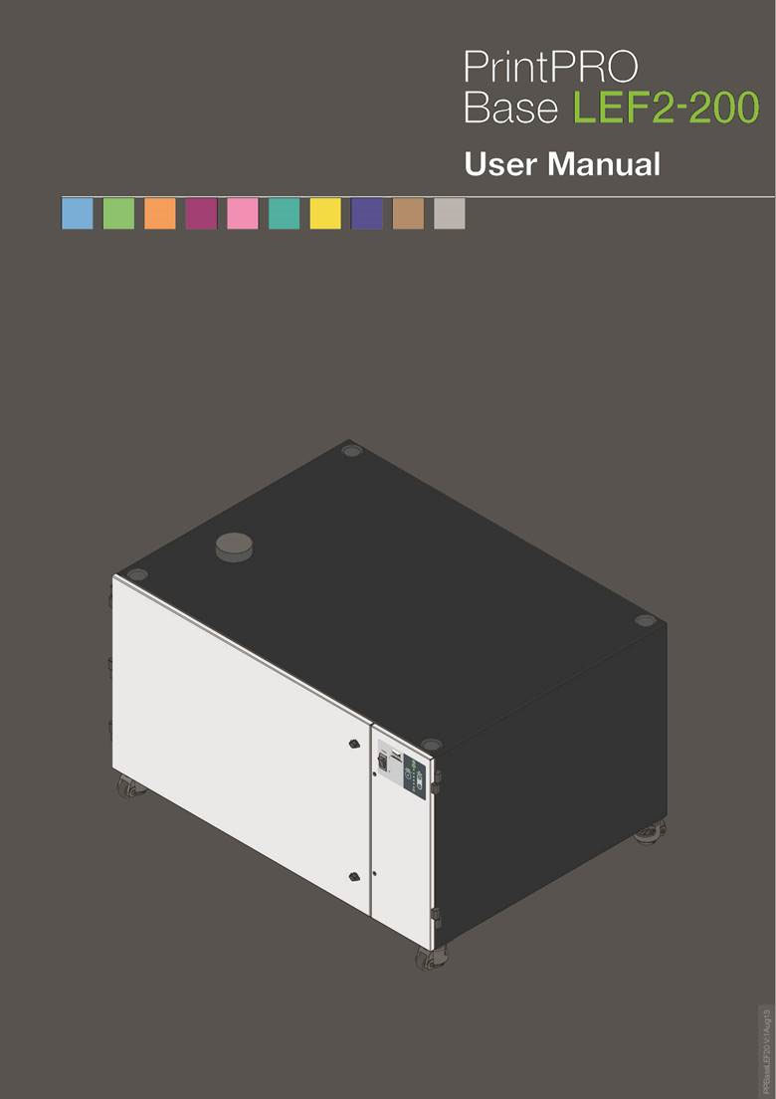

Overview

01

Overview
02

Safety Instructions
01

Important safety notes
Concerning symbols used on the extraction unit and referred to within this manual.
Danger
Refers to an immediately impending danger. If the danger is not avoided, it could result in death or severe (crippling) injury. Please consult the manual when this symbol is displayed.
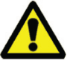
Warning
Refers to a possibly dangerous situation. If not avoided it could result in death or severe injury. Please consult the manual when this symbol is displayed.


Caution
Refers to a possibly harmful situation. If not avoided, damage could be caused to the product or something in its environment.
Important (Refer to manual)
Refers to handling tip and other particularly useful information. This does not signify a dangerous or harmful situation. Refer to manual when this symbol is displayed.
Electrical Safety
The BASE LEF system has been designed to meet the safety requirements of the Low Voltage Directive 2006/95/EC (previously numbered 73/23/EEC)
Warning
When working with the pump/motor housing open, Live 230/115 volt mains components are accessible. Ensure that the rules and regulations for work on live components are always observed.
Important
To reduce the risk of fire, electric shock or injury:
- Always isolate the system from the mains power supply before removing the pump/motor access panel.
- Use only as described in this manual.
- Connect the system to a properly grounded outlet.
Dangers to eyes, breathing and skin
Once used, the filter within the Base LEF system may contain a mixture of particulates, some of which may be sub-micron size. When the used filters are moved it may agitate some of this particulate, which could get into the breathing zone and eyes of the operative. Additionally, depending on the materials being lasered, the particulate may be an irritant to the skin.
This unit should not be used on processes with sparks of flammable materials or with explosive dusts and gases, without implementation of additional precautions.
Caution: When changing used filters always wear a mask, safety shoes, goggles and gloves.
Carbon selection
Please note that the media within the gas filter fitted in the Base LEF is capable of adsorbing a wide range of organic compounds. However, it is the responsibility of the user to ensure it is suitable for the particular application it is being used on.
BOFA Technical Service
If a problem arises with your Base LEF, please refer to the troubleshooting guide section of this manual. If the problem is still not resolved, please:
- Visit our website at www.bofa.co.uk for on-line help.
- Or contact the helpline on +44 (0) 1202 699444, Mon-Fri, 9am-5pm.
Email: Technical@bofa.co.uk
Serial Number
For future reference, fill in your Base LEF system details in the space provided. The serial number is on the rating label located on the side/rear of the unit.
Serial Number:
Safety Instructions

Safety Instructions
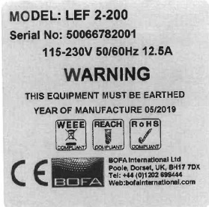
02

Warning and Information labels
The following listing details labels used on your Base LEF unit.
Goggles, Gloves & Mask Label

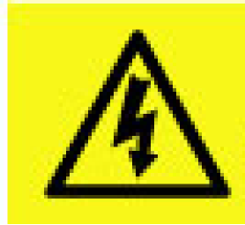
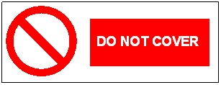
Location: Front face of the filter.
Meaning: Goggles, Gloves and Masks should be worn while handling used filters.
Do Not Cover Label
Location: Rear lower access panels
Meaning: Do not cover any louvers or holes adjacent to the label.
Electrical Danger
Location: Rear access panels & Front right door
Meaning: Removal of panels with this label attached will allow access to potentially live components.
Warning Label
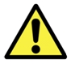
Location: Top left front door panel.
Meaning: Power should be isolated before the panel with this label attached is opened/ removed.

Serial Number Label
Location: Rear of unit next to mains inlet point.
Meaning: This label contains a variety of information about the extraction unit, including.

- Company name, Address & Contact number
- Extractor model
- Unit serial number
- Operating voltage range
- Maximum current load
- Operating frequency
- Year of Manufacture
- Relevant approval markings/ logos
PLEASE NOTE: If the equipment is used in a manner not specified by the manufacturer, the protection provided by the equipment maybe compromised.

Before installation
01

Inner transit packaging removal & unit placement
Before installation, check the extraction unit for damage.
All packaging must be removed before the unit is connected to the power supply.
Please read all instructions in this manual before using this extractor.

- Move the unit to the location where it is going to be installed and remove the outer packaging.
Caution
This unit should be installed in a well-ventilated area.
Due to the weight of the extractor suitable lifting equipment should be used and with regard to appropriate safety precautions. (See Appendix for product weight details)
Ensure that 500 mm space is available around any vented panels on the extractor to ensure adequate airflow.
2. With the unit in position unscrew the Red screw to lower the castor foot, so the unit castor wheel rises off the floor.

Locked Position
Unlocked Position
Caution
Do not block or cover the cooling vents on the unit, as this severely restricts airflow and may cause damage to the unit.
Caution
Under no circumstances should the exhaust outlet/s be covered as this will restrict the airflow and cause overheating.
4. Check the filter is located in the correct position before closing the door and securing the door latches.

Installation
01

The Base LEF has been designed to remove and filter fume containing potentially hazardous particulate and gases generated during manufacturing processes. Such hazardous substances are captured within a multistage filtration system after which the cleaned air is returned to the workplace.
General Guidelines for a successful installation
- Keep duct run length to a minimum
- Avoid sharp bends / turns in the ductwork
- Avoid multiple bends / turns in the ductwork
- Use a larger diameter duct where able
- Position the capture device as close as possible to the marking point. (if used on high speed lines, position the capture device slightly downstream)
Installing the LEF2-200 Printer to the Extractor
1. Install the short pipe onto the extractor flange.
- Lower the LEF printer onto the extractor.
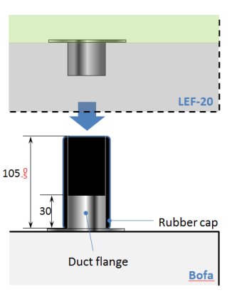
- Open the LEF printer door and secure the top flange over the short pipe.
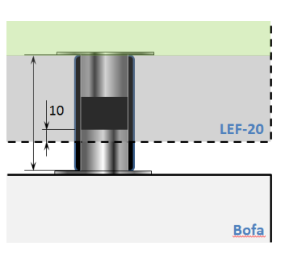

Exhausting filtered air outside
Your Base LEF extraction unit will have been fitted with an exhaust outlet spigot. This provides a connection point for exhaust pipework to be fitted. It is important to keep any ducting to a minimum, in order to reduce back pressure within the system.

Installation
02

Specification
Dimensions: Height 760mm Depth 950mm Width 1250mm
Weight: 135Kg
Voltage: 115-230V
Frequency: 50/60Hz
Full load current: 12.5A
Power: 1100w
Capacity:350m³/h / 206 CFM
Connection to Power Supply
Please follow the above specification when selecting the power supply outlet for the Base LEF system, ensure the power supply is suitable before connecting the Base LEF system.
Please do not use the lead with other devices
Check the Integrity of the electrical power cable, if the supply cord is damaged the extraction unit should not be connected to the mains. The supply cord should only be replaced by a BOFA engineer as an electrical safety test may be required after replacement.
The Base LEF system MUST be connected to a properly earthed outlet.
Connect the power cable to an isolated electrical supply.
The mains socket should be installed near the extractor it should be easily accessible and able to be switched On/ Off. The cable run should be arranged so as not to create a trip hazard.

Operation
01

Turning extraction unit On
Firstly the main isolation switch must be switched to the “On” position (Refer to section 1 for switch location) by depressing the Green side / (I) of the switch.

Powder Coated

To start the extraction unit press the front panel power button (refer to section 1 for switch location)
Setting the desired airflow
The Base LEF features manual flow control. This enables the user to set the required airflow rate, then over time as the filters begin to block the speed will need to be increased to compensate for any loss in performance caused by the added restriction of the partially blocked filter.
The extractor and all pipe work must be fully installed and connected before the airflow is set.

To set the airflow
- Press and hold the “Up” button to increase the airflow.
OR
Press and hold the “down” button to decrease the airflow.
- Release the button when the desired flow is reached.

Maintenance

01

Maintenance UK
It is a legal requirement, under regulation 9 of the COSHH regulations that all local exhaust ventilation systems are thoroughly examined and tested at least once every 14 months (typically carried out annually). The approved code of practice recommends that a visual check should be carried out at least once a week.
COSHH requires the annual inspection and testing to be carried out by a competent person and specifies that documentation results are recorded in a log.

Contact the seller for more information about inspection and certification.

Maintenance General
User maintenance is limited to cleaning the unit and filter replacement, only the manufacturers trained maintenance technicians are authorised to carry out component testing and replacement. Unauthorised work or the use of unauthorised replacement filters may result in a potentially dangerous situation and/or damage to the extractor unit and will invalidate the manufacturer’s warranty.
Cleaning the unit
The powder coat finished units can be cleaned with a damp cloth and non-aggressive detergent, do not use an abrasive cleaning product as this will damage the finish.

The cooling inlets and outlets should be cleaned once a year to prevent build-up of dust and overheating of the unit.
Replacing Filters
The Base LEF system will alert the user of a required filter change by the Green LED on the front of unit turning Red and Flashing. (See section 6.02 for filter change procedure) Or
When the extraction unit no longer removes the fume efficiently.

A log of the changes should be maintained by the user.

All filters are tested to BS3928. A certificate of conformity for each filter is available on request.
It is recommended that a spare set of filters are kept on site to avoid prolonged unit unavailability. Part numbers for replacement filters can be found on the filters fitted in your system. Alternatively, refer to the spare parts table in this manual.

To prevent overheating, units should not be run with a blocked filter condition, or with dust obstruction of Inlets / Outlets.

Maintenance

02

Filter Replacement
The filter needs replacing when the Green LED turns Red and starts flashing.

To remove and replace the filter follow the procedure detailed below.

- Isolate the electrical supply to the extractor
- Undo the catches on the front of the unit and open the door.
- (Refer to section 1 for filter location) remove the transit strap from the top of the filter.
- Remove the filter from the unit.
- Once removed it is recommend that the used filters are bagged and sealed.
- Slide the new filter into position making sure it is pushed all the way in and is located correctly on the gasket underneath.
- Close the door and fasten the 2 latches
The filter MUST be fitted when the extractor is in use.

Troubleshooting

01

In the unlikely event of an issue with your extraction unit please contact your local representative.

. Replacement Parts

01

Consumable Spares
The filter should be replaced when instructed to do so by the Base LEF or when the extractor no longer removes the fume efficiently (see section 6 for replacing the filters)
To maintain performance it is important that the filters are replaced with identical BOFA filters. To re-order please refer to the Filter number printed on the filter installed in your extraction unit.

Maintenance Protocol
Please record filter changes on the table below.

Unit Serial Number:
Combined filter
Date | Engineer

Filter Part Number
When ordering new filters for you Base LEF 2-200 please use the table below or lookup the part number attached to the filter fitted within your extraction unit.
Unit | Combined Filter Part Number
Base LEF 2-200 | A1030158
Base LEF 2-200  USA | A1030228

Filter disposal
The Combined filters are manufactured from non-toxic materials. Filters are not re-usable, cleaning used filters is not recommended. The method of disposal of the used filters depends on the material deposited on them.

For your guidance

Deposit | EWC Listing* | Comment
Non Hazardous | 15 02 03 | Can be disposed of as non-hazardous waste.
Hazardous | 15 02 02M | The type of hazard needs to be identified and the associated risks defined. The thresholds for these risks can then be compared with the amount of material in the filters to see if they fall into the hazardous category, if so, the filters will need to be disposed of in line with the local/national regulations.
*European Waste Catalogue

Fuses
The Extraction unit has an internal transformer which is protected by a fuse. Should a replacement fuse be required it is important that this matches the specification given below.

Unit | Item Protected | Fuse Rating | Full load current | Voltage
Base LEF 2-200 | 12v Transformer | 1A | <0.1A | 110-230V

System Specifications

01
Unit: Base LEF 2-200 Specification
Capacity: 350m³/h (206 CFM)
Weight: 135Kg (297lbs)
Motor: Centrifugal Fan
Output: 1100w
Electrical supply: 115-230V
Hertz: 50/60Hz
Full Load Current: 12.5A
Noise Level: Below 60dB (A)
(at typical operating speed)
Size:
 | Metric (mm) | Imperial  (inches)
Height | 760 | 30.0
Depth | 980 | 38.6
Width | 1250 | 49.3

Filters:
Filter Type | Surface area | Efficiency
Combined filter | 3.45m² | 99.997% @ 0.3micron
Combined Filter (Gas section)
Filter Type | Carbon type | Amount
Combined filter  ( Gas ) | Activated carbon | 20kgs

Environmental operating range:
Temperature: +5ºC to + 40ºC
Humidity: Max 80% RH up to 31ºC
Max 50% RH at 40ºC

. Contact Information

BOFA Headquarters
21-22 Balena Close
Creekmoor industrial Estate
Poole
Dorset
BH17 7DX
UK
Phone: +44 (0) 1202 699444
BOFA Americas
303 S.Madison Street
Staunton
Illnois
62088
USA
Phone: 001 (618) 205-5007

